# PCWG Analysis Tool Version 0.6.0 Release Notes

## Introduction

Release 0.6.0 marks a major step forward for the PCWG Analysis Tool (PCWG-AT). This release implements several points of feedback raised by PCWG members during 2015-2016, specifically:

* **Usability**: Several changes have been made to make PCWG-AT easier to use.
* **Turbine parameters moved**: Following user feedback the turbine parameters (cut-in speed, cut-out speed, rated power, diameter and hub height) have been moved from the Analysis to the Dataset. This change acknowledges that these turbine parameters are inherently tied to dataset and will not charge according to what analysis is performed. This change has also helped simplify the implementation of the dataset portfolio feature (see below).
* **Faster and easier PCWG-Share-X participation**: A new dataset portfolio feature has been introduced to reduce the time and effort required to participate in PCWG-Share-X. After initial set up participation should now take ‘one click’.
* **Enhanced Relative File Path Support**: The handling of relative file paths within PCWG-AT has been made more robust.

Additionally there has been a substantial overhaul of the PCWG-AT source code structure, specifically the separation of the code into several component libraries. This reorganisation has helped increase the maintainability of the code and will hopefully lead to faster development and issue resolution in the future.

## Issue Tracking

Anyone wishing to submit issues/bugs/suggestions for the PCWG-AT should do so via GitHub using the link <https://github.com/peterdougstuart/PCWG/issues> and clicking the ‘New Issue’ button.

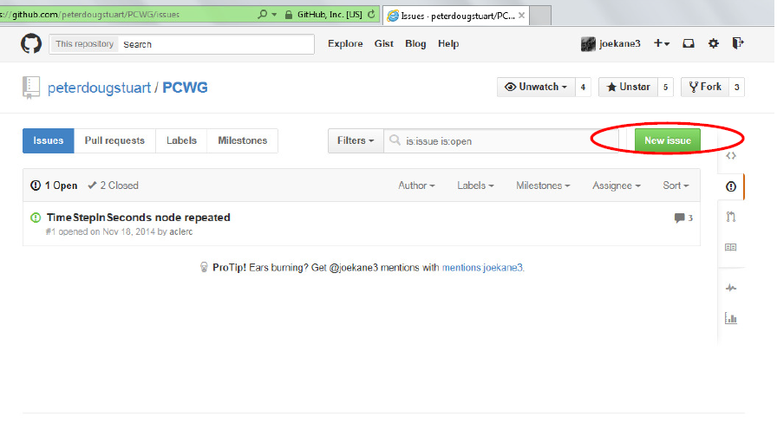

**Usability Enhancements**

The PCWG-AT user interface has gone through a major overhaul. The most notable change is the restructuring of the user interface to use tabs. This has drastically simplified the process of setting up datasets and analyses by making it easier to navigation to individual settings.

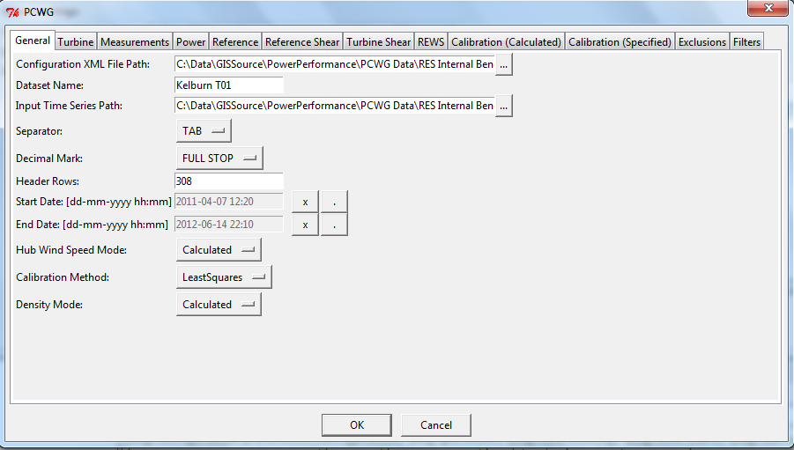

Figure 1. PCWG User Interface with the addition of tabs.

Additionally a new grid control has been introduced which replaces the somewhat ugly & cumbersome grid control in previous versions.

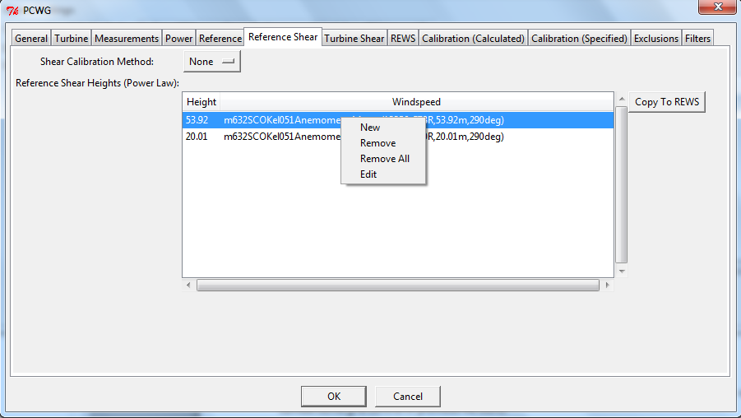

Figure 2. PCWG User Interface with the addition of new grid control

The grid control supports an intuitive context menu (right mouse-click on windows systems) which supports operations such as edit, new, remove etc. Double-clicking on an item within the grid can also be used to edit.

## Turbine Parameters Moved

Following user feedback the turbine parameters (cut-in speed, cut-out speed, rated power, diameter and hub height) have been moved from the Analysis to the Dataset. This change acknowledges that the turbine parameters are inherently tied to dataset and will not charge according to what analysis is performed. In addition to being a logical step to take, this change has also helped simplify the implementation of the dataset portfolio feature (see next section).

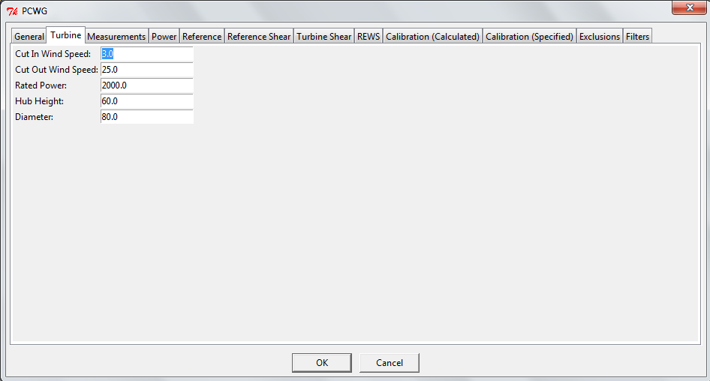

Figure 3a. New location of turbine parameters on dataset input form.

Dataset files defined before this change can still be opened in the tool, however the turbine parameters must be added before they can be re-saved. Therefore to upgrade a dataset with these new parameters just follow the following simple steps.

1. Open the dataset (either via the analysis dialog or the dataset portfolio dialog).
2. Click on the turbine tab
3. Enter the missing parameters
4. Hit OK.

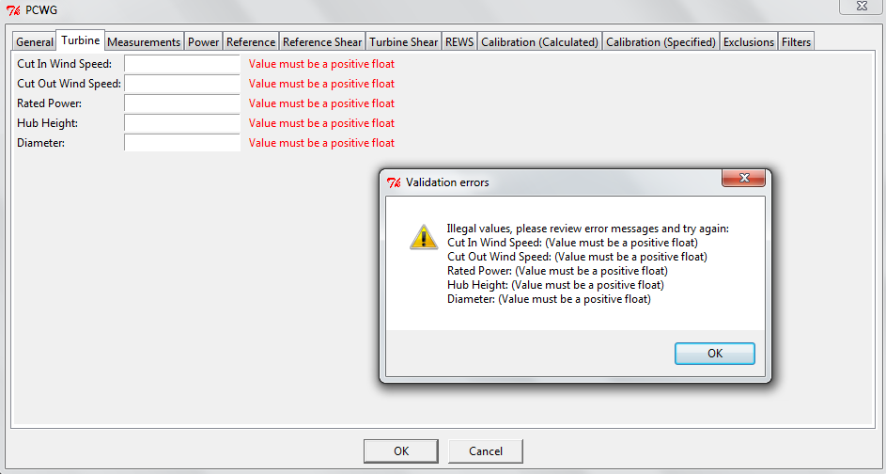

Figure 3b. New location of turbine parameters on dataset input form.

**Faster and Easier PCWG-Share-X Participation**

A new dataset portfolio feature has been introduced to reduce the time and effort required to participate in PCWG-Share-X. The core concept is that once you’ve defined your datasets it should only take ‘one click’ to re-run them in a new iteration of PCWG-Share-X e.g. PCWG-Share-1, PCWG-Share-1.1, PCWG-Share-2 etc.

A dataset portfolio is just a simple collection of datasets which can be run through standard analyses as a batch. To create a new data set press the ‘New’ button on the home screen.

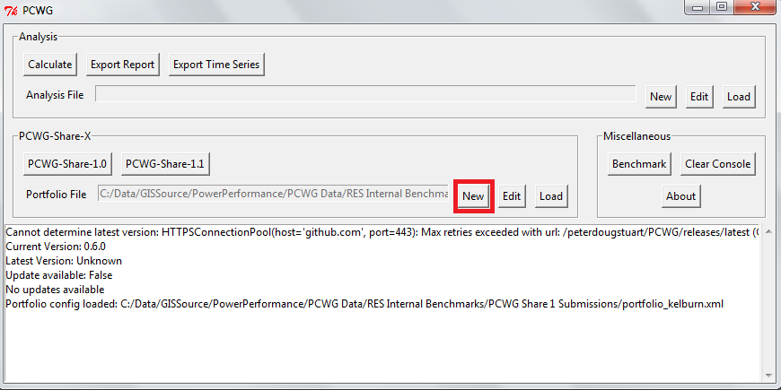

Figure 4a. Launching the new dataset portfolio dialog

The dataset portfolio dialog is very simple, just a description and a list of datasets.

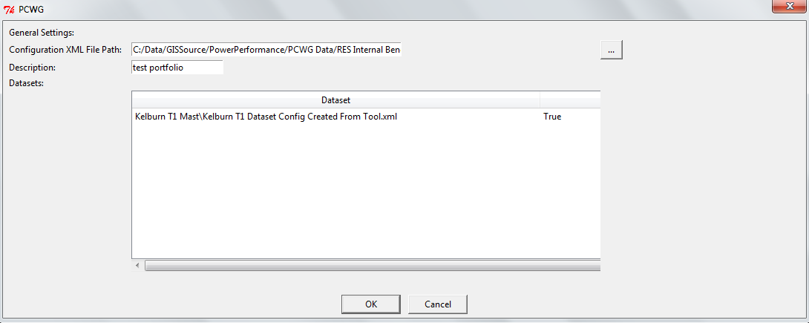

Figure 4b. The dataset portfolio dialog

A context menu (right-click on windows systems) can be used to add, edit and remove datasets from the portfolio.

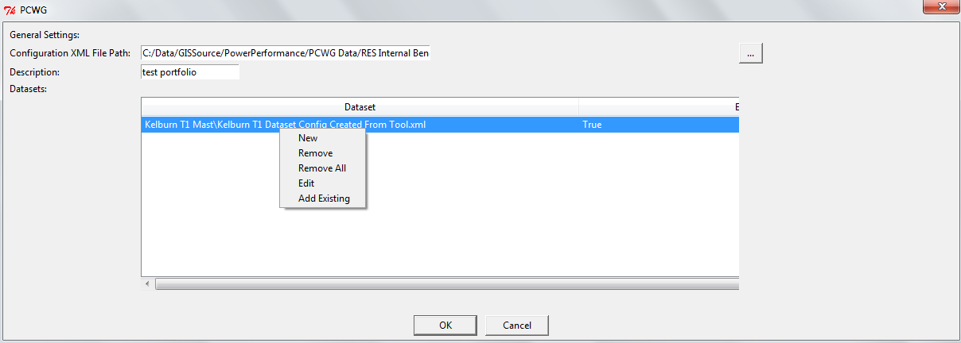

Figure 4c. The dataset portfolio context menu.

Once a dataset portfolio is defined the standardised PCWG-Share-X analysis can be executed using the relevant button on the home screen.

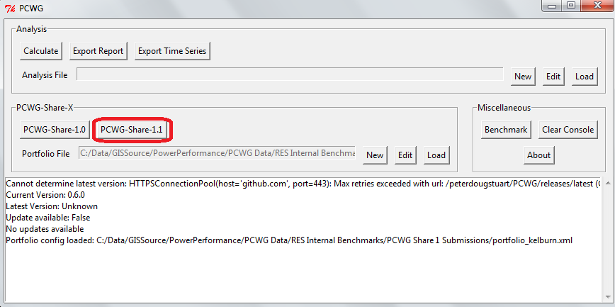

Figure 4d. Launching the standardised PCWG-Share-X analysis

**Enhanced Relative File Path Support**

The PCWG uses several different types of file which reference each other, specifically:

* A dataset references:
  + A time series data file
* Analysis references:
  + A Power Curve File
  + One or more dataset files
* A portfolio references:
  + One or more dataset files

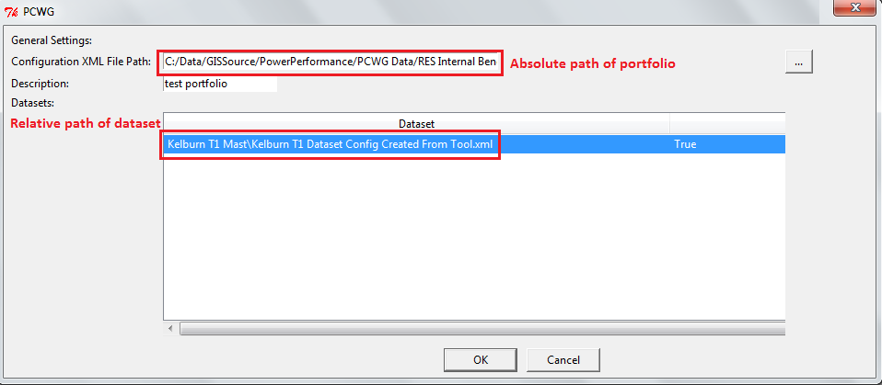

Figure 3. Absolute and relative paths in a portfolio

In previous versions of the tool the references linking files could easily become confused. For example if an analysis and its associated datasets were moved to a new folder then the links between them could become broken. In the new version as long as the relative locations of the files are consistent before and after the links will stay intact (see example below).

This enhancement is particular useful is you are storing your files in a source control system like SVN or GIT which have consistent relative paths, but often different absolutes paths depending on the user set up.

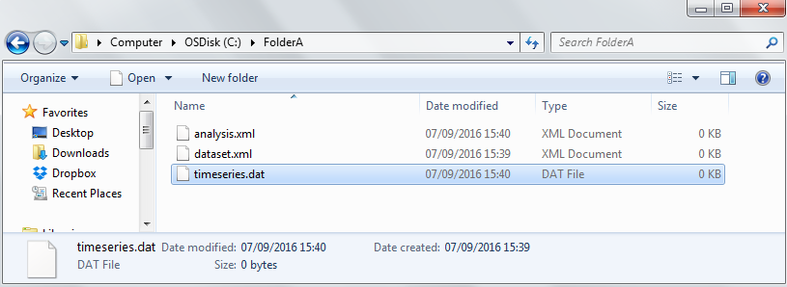

Figure 4a. Example file move with consistent relative locations (before). Dataset.xml has a reference to timeseries.dat and analysis.xml has a reference to dataset.xml

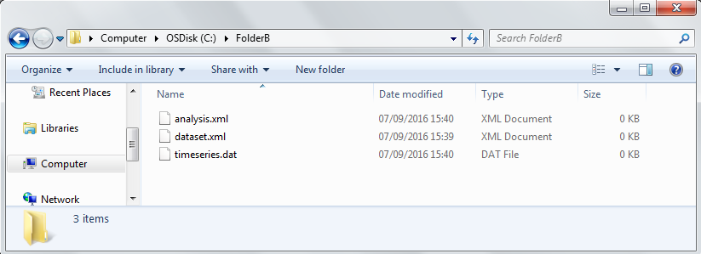

Figure 4b. Example file move with consistent relative locations (after). The association between the files remains intact